Function Requirements:
- 2 USB-C host connections (host machine), 2 USB-A peripheral connections (keyboard, mouse)
- Small and sleek.
- Switch to actuate analog switch

Architecture:
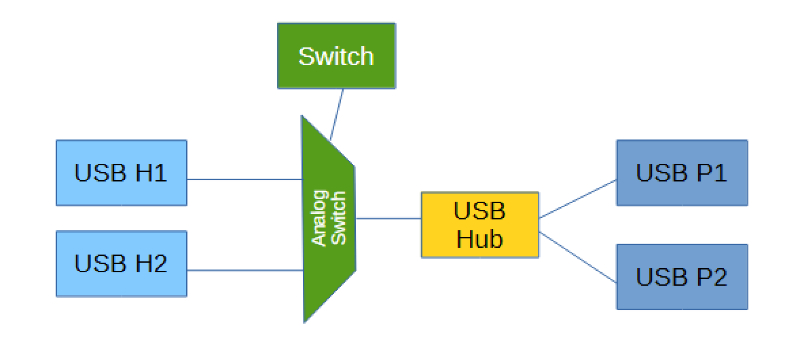
- Power incoming from both 5V USB-C host machines, using a diode to route the current and prevent sourcing the other connection.
- Cut 5V to 3.3V / 1.8V depending on the IC (requires buck converter / LDO)

IC Info:
In order for an IC to be selected, it must be continuously available and easy to source from reputable distributors (Mouser / DigiKey preferably). Also, the package must make sense within the context of the project.

IC | Part # | VDD
2 Port USB Hub: | TUSB4020BI | VDD11 1.1V, VDD33 3.3V
Analog switch: | TMUXHS221 | 3.3V
USB-A 2.0 Recep: | 87583-3010RPALF | -
USB-C 2.0 Recep: | 2171750001 | -
Buck 5V – >3.V: |  | 5V
Buck 5V – >1.1V: |  | 3.3V
Physical switch: |  | -

